Team Cindiesel Dungeon Document

Setting/Theme: The setting of the project is the Hogwarts castle. The character is a wizard who will be allowed to choose their school (Hufflepuff, Ravenclaw, Gryfindor, Slytherin) and based off of the class they choose they will receive different treatment from the mobs, rooms, and may even get special items for them to hold. The wizard will start off with a basic wand and then as the continue to play the game and pick up items their pack of items will change and get better. The ultimate old of the game is for the wizard to find and kill Voldemort, but along the way they will face a lot of different obstacles. All of the wizards will be able to interact and attack each other and defeating each other or potentially forming a truce with each other. The game will end with the death of Voldemort or if all of the players have been defeated prior to anyone finding Voldemort who can spawn in any room.

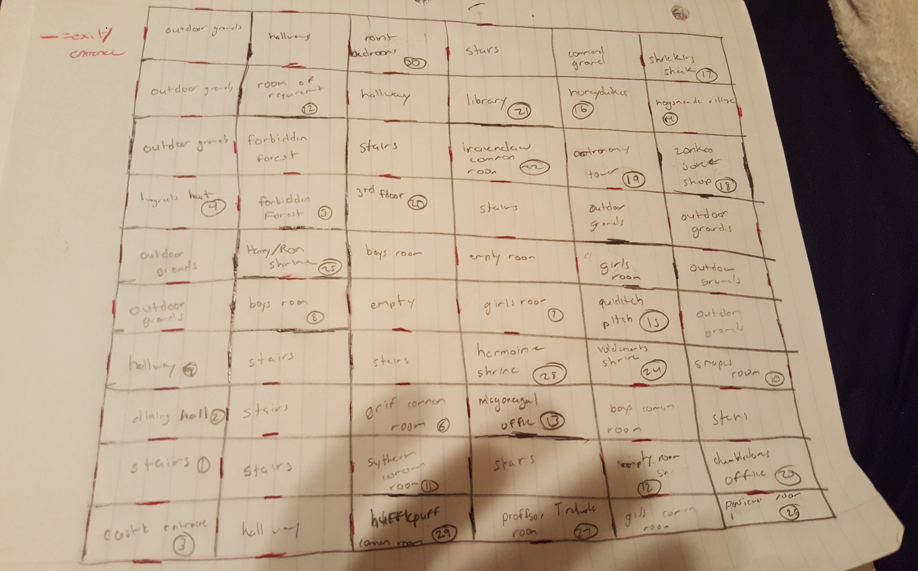Map :